Financial Accounting & Analysis
April 2025 Examination

Q1. Prepare final accounts from the following balances -
Trial Balance as on 31.03.2024
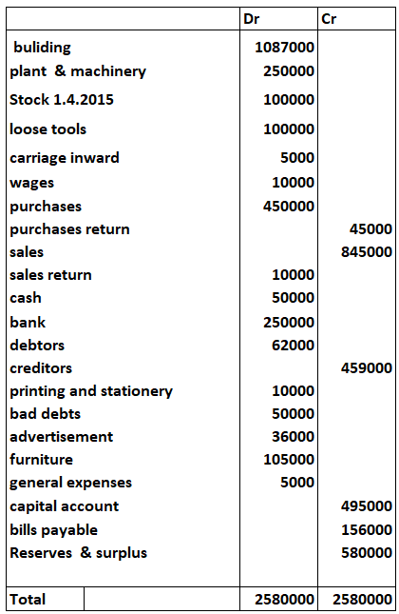
Addition information:
• The closing inventory as on 31.03.2024 was valued at Rs. 3,68,500.

• Depreciation on plant @ 15% and on Building @ 10%.
• Outstanding printing and stationery expense Rs. 5000.
• Prepaid advertisement expense Rs. 15000. (10 Marks)

Ans 1.

Introduction
The preparation of final accounts is a critical process in financial accounting, where the financial position and performance of a business are summarized. These statements include the Trading and Profit & Loss Account and the Balance Sheet. Final accounts help stakeholders assess profitability, operational efficiency, and financial stability. The trial balance serves as the foundation for this process. Adjustments, such as depreciation, outstanding expenses, and closing inventory, ensure

It is only half solved

Buy Complete from our online store

https://nmimsassignment.com/online-buy-2/

NMIMS Fully solved assignment available for session APRIL 2025,

your last date is 26th March 2025.

Lowest price guarantee with quality.
Charges INR 199 only per assignment. For more information you can get via mail or Whats app also
Mail id is aapkieducation@gmail.com

Our website www.aapkieducation.com
After mail, we will reply you instant or maximum
1 hour.
Otherwise you can also contact on our
Whatsapp no OR Contact no is +91 8755555879

Q2. Raj Limited provides the following information for the immediately preceding two years. From the given information prepare Comparative Income Statement of the company
for the two- year period: (10 Marks)

Particulars | 2023 | 2024
Particulars | Rs. Million | Rs. Million
Sales | 5,000 | 3,750
Cost of goods sold | 3,000 | 2,450
Operating expenses | 750 | 490
Financial expenses | 500 | 340
Income tax | 150 | 95
Net profit | 600 | 375

Ans 2.
Introduction
A Comparative Income Statement is a key tool in financial analysis that enables the comparison of a company’s financial performance over two or more periods. It highlights changes in revenue, expenses, and profitability, providing insights into the company’s growth trends, efficiency, and areas of improvement. By showing both absolute and percentage changes, a comparative income statement makes it easier for stakeholders to understand how various income statement elements have evolved. In this exercise, we analyze Raj Limited’s income statement for 2023 and 2024 to assess its performance, identifying key trends and underlying causes for any changes in profitability. This analysis uses critical accounting concepts such as cost control,

Q3(a).Dividend is the distribution of profits by a company to its shareholders. Companies generally pay two types of dividends: Interim dividend and Final dividend. You are required to explain the term Dividend and explain the two types of dividends.
(5 Marks)
Ans 3a.
Introduction
A dividend is the portion of a company’s profits distributed to its shareholders as a reward for their investment in the company. It reflects a company’s financial health, profitability, and commitment to providing returns to shareholders. Dividends can be paid in cash, shares, or other forms and are usually declared by the company's board of directors. There are primarily two types of dividends: interim dividend and final dividend. These distributions not only signal a company's performance

Q3(b). In order to take management decisions for a company, it is important to analyze the financial statements of the company in detail with the help of various financial analysis techniques. Explain in one sentence each the 5 techniques of analyzing financial statements. (5 Marks)
Ans 3b.
Introduction
Financial statement analysis is the process of evaluating a company’s financial data to assess its performance, financial health, and decision-making efficiency. It enables management, investors, and other stakeholders to make informed decisions. Various techniques, including ratio analysis,

