**Financial Accounting & Analysis**

**December 2024 Examination**

**Q.1. Mr. Manoj has shared the following information with you in the form of a Trial Balance. You are required to prepare Final Accounts for Mr. Manoj in horizontal format (i.e., the T format) for the year ending 31.03.2024.**

**Trial Balance as on 31.03.2024**

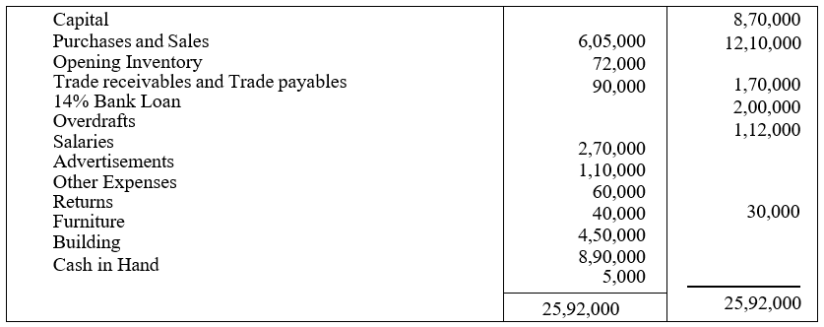

**Addition information:**

**The closing inventory as on 31.03.2024 was valued at Rs. 1,00,000. (10 Marks)**

**Ans 1.**

**Introduction**

The process of preparing final accounts is crucial for any business, as it presents the financial position and performance over a specified period, usually the financial year. In the case of Mr. Manoj, the information provided in the form of a trial balance is used to prepare the final accounts, which include the Trading and Profit & Loss Account and the Balance Sheet for the year ending 31st March 2024. The trial balance is a summary of all the debit and credit balances extracted from the ledger accounts. However, for

It is only half solved

Buy Complete from our online store

<https://nmimsassignment.com/online-buy-2/>

NMIMS Fully solved assignment available for**session DEC 2024,**

your**last date is 29th Nov 2024**.

Lowest price guarantee with quality.

Charges**INR 199 only per assignment.**For more information you can get via mail or Whats app also

Mail id is [aapkieducation@gmail.com](mailto:aapkieducation@gmail.com)

Our website [www.aapkieducation.com](http://www.aapkieducation.com/)

After mail, we will reply you instant or maximum

1 hour.

Otherwise you can also contact on our

Whatsapp no OR Contact no is +91 8755555879

**Q.2. Prepare cash flow statement for X Ltd. from the following information provided for the year: (10 Marks)**

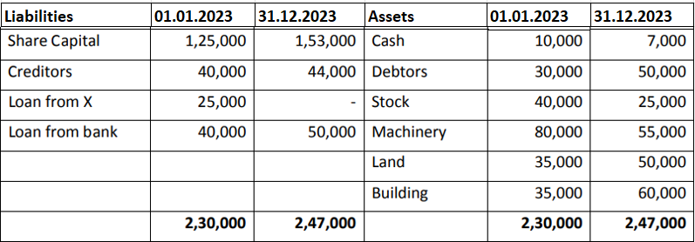

**During the year 2023, a machine costing Rs. 10,000 and accumulated depreciation**

**Rs. 3,000 was sold for Rs. 5,000.**

**Ans 2.**

**Introduction**

A cash flow statement is a critical financial report that shows the movement of cash and cash equivalents during a specific period. It provides insights into how a company generates and uses cash from its operating, investing, and financing activities. The cash flow statement for X Ltd. for the year 2023 will be prepared using the information provided, focusing on cash inflows and outflows. The sale of machinery and the changes in various assets and liabilities will also play a role in determining the net cash flow for the year. Cash flow statements are particularly valuable as they highlight the liquidity position of a company and help stakeholders assess how well the company manages its cash to meet short-term obligations and fund long-term growth. In this case, we will use the indirect method to

**Q.3 (a) The following balances appear in the trial balance of a firm as on 31.03.2024:**

|  |  |
| --- | --- |
| **Provision for bad and doubtful debts (as on April 1st 2023)** | **2500** |
| **Debtors** | **50000** |
| **Bad Debts** | **4000** |

**The firm has proposed to maintain a provision of 10% on debtors for bad and doubtful debts. You are required to give the treatment of the above adjustment in the financial statements of the firm. (5 Marks)**

**Ans 3a.**

**Introduction**

The provision for bad and doubtful debts is an accounting adjustment used to anticipate future losses from uncollectible receivables. In this case, the firm has a balance of debtors, bad debts, and an existing provision for bad debts as on April 1st, 2023. The firm proposes to maintain a provision of 10% on its debtors for the year ending March 31, 2024. This adjustment will be reflected in the financial statements to ensure the firm's accounts accurately represent potential losses from

**Bottom of Form**

**Q.3 (b) Match the accounting concept with the description of the concept that is given in the description column: (5 Marks)**

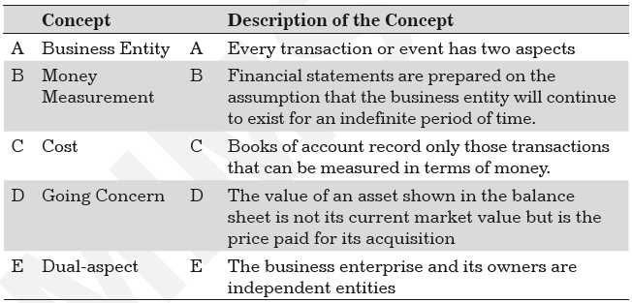

**Ans 3a.**

**Introduction**

In accounting, several key concepts or principles guide the preparation and presentation of financial statements. These concepts ensure consistency, reliability, and accuracy in the financial reporting process. Understanding these concepts is crucial for interpreting the financial performance and position of a business. The matching of accounting concepts with their correct descriptions is essential in ensuring that financial data is accurately recorded, classified, and summarized. This question requires associating the accounting concepts with their respective descriptions provided in the table.

**Concept and Application**

**Business Entity Concept**