Sales Management
April 2024 Examination

Q.1 The Smart Cube is a global provider of research and analytics solutions, primarily serving the financial services, retail, life sciences, energy and industrials sectors. Addressing the needs of businesses in the intelligence age, their customized solutions provide a truly connected approach, delivered by talented minds and intelligence platform, rich with knowledge, cutting edge tools and advanced analytics. They work with a third of companies in the Fortune 100, helping them make smarter decisions, accelerate value, and gain a competitive edge.Headquartered in the UK with additional offices in the USA, Switzerland, Romania and India.
You are appointed as the Vice President Sales – Analytics for India office. How will you train your team on Personal selling? Do you think personal selling is the bestselling method for selling technology solutions and services? (10 Marks)

Ans 1.
Introduction
In the dynamic realm of sales, particularly within the technology solutions and services sector, personal selling emerges as a pivotal strategy, especially for a company as globally integrated and intelligence-driven as The Smart Cube. Personal selling transcends mere transactional exchanges, fostering deeper, more meaningful relationships between the seller and the buyer. This approach is especially crucial in sectors where the products or services offered are complex, highly customizable, and require a significant degree of trust and understanding between the parties involved. As the newly appointed Vice President of Sales – Analytics for the India office of The Smart Cube, the task at hand is not just to train the sales team but to imbue them with the nuanced skills and strategic mindset required for personal
It is only half solved

Buy Complete from our online store

https://nmimsassignment.com/online-buy-2/

NMIMS Fully solved assignment available for session APRIL 2024,

your last date is 28th MARCH 2024.

Lowest price guarantee with quality.
Charges INR 299 only per assignment. For more information you can get via mail or Whats app also
Mail id is aapkieducation@gmail.com

Our website www.aapkieducation.com
After mail, we will reply you instant or maximum
1 hour.
Otherwise you can also contact on our
whatsapp no 8791490301.
Contact no is +91 87-55555-879

Q2. Prataap Snacks is a leading Indian Snacks Food Company and continues to win the trust of consumers day by day. And why won’t they?Akhir, “dildaar hain hum!” is the tag line.
Desi Namkeen and an Indian palate are ageless companions, just like chips and dips, rings and fingers or good people and noble ventures. This is a story of such a venture that brought versatility, a wide traditional and international variety, exceptional quality and above all, a ‘dildaar’ quantity of snacks across India. The story of the brand - Yellow Diamond. In the early 90s, an idea struck an Indore-born, US student named Amit Kumat. The idea of pairing something papad-crunchy with a steaming plate of dal-rice…Chips! His belief in the power and potential of snacks as a sunrise category firmed up then itself. A few years later, in 2004 entrepreneur, Amit Kumat along with Apoorva Kumat and Arvind Mehta turned this idea into a home-grown snacks offering, named Yellow Diamond. Salman Khan was appointed brand ambassador in 2017.

You are the national sales head and reporting to Mr. Amit Kumat. He has asked you to work on restructuring the sales organization. Would you opt for product based or geographical based sales structure? Support your answer with a valid reason. (10 marks)
Ans 2.
Introduction
In the dynamic landscape of the Indian snacks industry, Prataap Snacks, under its flagship brand Yellow Diamond, has made significant strides in capturing the essence of Indian taste preferences with its diverse range of products. The brand’s journey, from its inception by Amit Kumat and his partners in 2004 to becoming a household name with Bollywood superstar Salman Khan as its brand ambassador in 2017, illustrates its successful penetration and acceptance in the Indian market. Given the task by Mr. Amit Kumat to restructure the sales organization, the decision between adopting a product-based or geographical-based

Q.3 Padcare Labs is a Pune based organization offering menstrual hygiene and healthcare solutions to women. Their clients entail the following corporates:
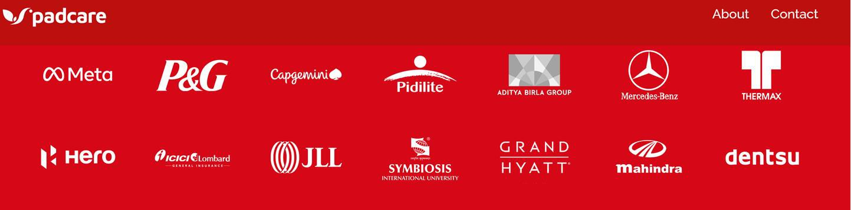
It has received funding and is now on an expanision spree and Ms Priyanka Sharma has been appointed as Head of Corporate Sales.
a. Ms. Priyanka Sharma wants to implement CRM solution for increasing sales. Do you think implementing CRM will increase customer retention? (5 Marks)
Ans 3a.
Introduction
Padcare Labs, a Pune-based organization specializing in menstrual hygiene and healthcare solutions for women, is poised for expansion under the leadership of Ms. Priyanka Sharma as Head of Corporate Sales. As part of this growth strategy, Ms. Sharma is considering implementing a Customer Relationship Management (CRM) solution to boost sales. This

b. Ms. Priyanka Sharma has undergone SPIN training. Explain spin theory with examples. (5 Marks)
Ans 3b.
Introduction
SPIN Selling is a renowned sales methodology developed by Neil Rackham, focusing on asking effective questions to uncover customer needs and preferences. Ms. Priyanka Sharma's training in SPIN Selling equips her with the skills to navigate complex sales situations and build stronger client relationships. This analysis explores the SPIN theory and its application

