International Marketing
April 2024 Examination

Q1. In 2008 Tata Motors paid the Ford Motor Company $2.3 billion for UK based automakers Land Rover and Jaguar. Ford had acquired Jaguar in 1989, as it lacked a high end luxury model. Tata Motors was also reeling under the global recession crisis of 2008 and was facing a slump in demand for cars in India. In fact in its first year of ownership it lost $500 million on Jaguar Land Rover. Then, as global economy rebounded so did sales of luxury cars. After almost 15 years of acquisition do you think JLR has prospered under the ownership of TATA motors? Are they facing challenges of new market entry? What are the other challenges faced by TATA motors? (10 Marks)

Ans 1.
Introduction
The acquisition of Jaguar Land Rover (JLR) by Tata Motors in 2008 marked a significant milestone in the global automotive industry, particularly in the context of international marketing and corporate strategy. This move, executed amidst the challenging backdrop of the 2008 global financial crisis, represented not only a bold expansion for an Indian multinational into the luxury car segment but also a significant shift in the dynamics of the automotive industry. Tata Motors, a dominant player in the Indian market known for its robust, economical models, ventured into uncharted territory with the acquisition of two iconic luxury brands. This strategic decision was fraught with risks and opportunities,
It is only half solved

Buy Complete from our online store

https://nmimsassignment.com/online-buy-2/

NMIMS Fully solved assignment available for session APRIL 2024,

your last date is 28th MARCH 2024.

Lowest price guarantee with quality.
Charges INR 299 only per assignment. For more information you can get via mail or Whats app also
Mail id is aapkieducation@gmail.com

Our website www.aapkieducation.com
After mail, we will reply you instant or maximum
1 hour.
Otherwise you can also contact on our
whatsapp no 8791490301.
Contact no is +91 87-55555-879

Q2. Starbucks takes coffee culture around the world! (10 Marks)
There were 35,711 thousand Starbucks stores worldwide in 2022. This figure also included other segments owned by the coffee-chain such as Siren Retail. Starbucks units have grown almost every year over the past decade. The only drop was in 2009, most likely due to the global financial crisis. Global expansion has ultimately allowed the coffee-chain to almost double its number of locations over the past 10 years.
When looking at Starbucks stores by country the most Starbucks stores were located in the U.S., the company’s home nation. In 2022, there were more than 15 thousand Starbucks locations in the U.S. alone. While the U.S. has the most stores, in recent years the company’s international presence has shown tremendous growth. As a result, in 2018, for the first time, there were more international Starbucks stores than in the U.S. – a gap which has widened considerably.
What is the market expansion strategy of Starbucks? It was only in 2018 Starbucks entered Italy. What were the challenges faced by Starbucks to enter Italy? After 5 years in operations, do you think it was a right decision to enter Italian shores?
Ans 2.
Introduction
Starbucks, a global coffee giant, exemplifies a remarkable journey in international market expansion, becoming a ubiquitous presence in the global coffee industry. With a footprint of over 35,000 stores worldwide by 2022, Starbucks has demonstrated an impressive growth trajectory, particularly in the last decade. This expansion is noteworthy given the only dip in growth occurred during the 2009 financial crisis. The company’s strategic foray into various international markets, including its entry into Italy in 2018, a nation with a deeply entrenched coffee culture, reflects Starbucks' nuanced approach to globalization. The decision to enter

Q3. Ikea is a global home furnishing brand. They have a vision to make life better for their customers. As on Aug 2023, Ikea had 460 stores in 62 markets. The first Ikea store was opened in 1958 in Sweden and the latest one is opened in Surabaya, Indonesia. It started its
India operations by opening its first store in Hyderabad.

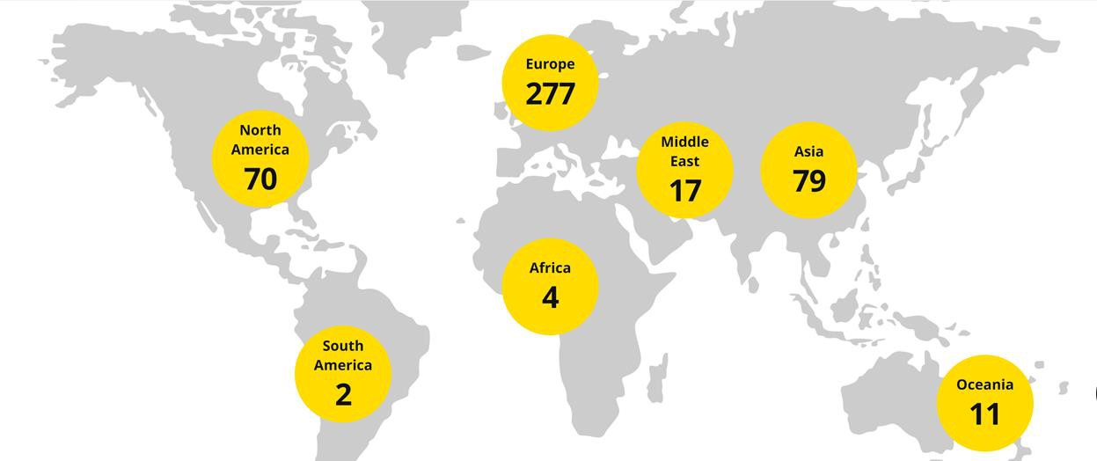

a) How important is to understand the culture of the country? Is it an essential step in market research? (5 marks)
Ans 3a.
Introduction:
Understanding the culture of a country is pivotal for any global brand like IKEA, especially when it is expanding its reach into diverse markets. Culture encapsulates the shared values, beliefs, behaviors, and artifacts making up a society’s way of life. It directly influences consumer behavior, preferences, and expectations. For a home furnishing brand, where products are intimately connected to customers' lifestyles, comprehending the cultural

b. Do you think even the marketing campaigns of IKEA are impacted by the culture difference. Elaborate with an example. (5 marks)
Ans 3b.
Introduction:
Marketing campaigns are the touchpoints through which a brand communicates its value proposition to its target audience. For a global entity like IKEA, these campaigns must be carefully tailored to align with the cultural fabric of each market. The effectiveness of marketing strategies hinges on the brand's ability to resonate with local cultural norms, values, and consumer behavior. Cultural differences impact not only the messaging but also

