Decision Analysis & Modeling
June 2023

Question 1. A company has three factories P1, P2, and P3 with capacity of 400, 300, and 300 units. It has four warehouse W1, W2, W3 and W4 with demand of 50, 150, 350 and 450 units. Cost per unit for transportation is given in the table below. Solve the following transportation problem to minimum cost. Find IFS by Least cost method (LCM) and transportation cost
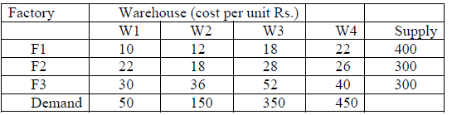
Answer:
Introduction
The problem that has been presented to us is a transportation issue, and it involves three different factories (F1, F2, and F3) and four different warehouses (W1, W2, W3, and W4), all of which have their own unique supply capacities and demand quantities. The goal is to minimize the cost of transportation while simultaneously satisfying the limits imposed by supply and demand. In a cost matrix, the amount of money It is only half solved

Buy Complete from our online store

https://nmimsassignment.com/online-buy-2/

NMIMS Fully solved assignment available for session JUNE 2023,

your last date is 29th May 2023.

Lowest price guarantee with quality.
Charges INR 299 only per assignment. For more information you can get via mail or Whats app also
Mail id is aapkieducation@gmail.com

Our website www.aapkieducation.com
After mail, we will reply you instant or maximum
1 hour.
Otherwise you can also contact on our
whatsapp no 8791490301.
Contact no is +91 87-55555-879
Question 2. Calculate EMV, EPPI, EVPI, EOL and determine which is the best course of action:
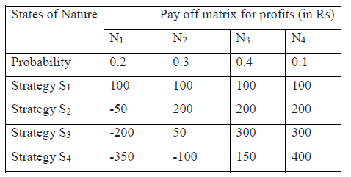
Answer:
Introduction
Introduction:
Estimated Monetary Value (EMV), Expected Perfect Information (EPI), Expected Value of Perfect Information (EVPI), and Expected Opportunity Loss (EOL) are some decision criteria used in decision making in the face of ambiguity. By taking into account the likelihood of various outcomes and the value of those outcomes, these criteria aid in selecting the most appropriate action to take. Here, the probabilities of various natural states and the corresponding payoffs for various tactics are

Question 3
a Why we must do post optimality test in LPP (sensitivity Analysis)?
b. In solving linear programming problem what are the use of slack variable, surplus variables, and artificial variables.?
Answer 3a:
Introduction
Post-optimality testing, which is often referred to as sensitivity analysis, is an essential phase in linear programming problems (LPPs) that is used to evaluate the consistency and dependability of the optimal solution that has been obtained. When doing a sensitivity analysis, the task is to investigate how shifts in the input parameters of the LPP, like the coefficients of the objective function or the constraints, influence the best solution and the objective value that is associated with i
Answer 3b
Introduction
In linear programming, the links between the constraints and the objective function are represented by slack variables, surplus variables, and fake variables, depending on whether the constraints take the form

