Corporate Finance
April 2023 Examination

Q1. Calculate WACC with the following information. Which source of funding is most desirable and why? (10 Marks)
PQR Ltd. is coming out with a new equity issue of Rs. 10 lacs par value Rs. 100/share. The cost of issuing external equity is around 5%. Shareholders expect a return of 16% p.a. for the risk involved in parking their funds in PQR Ltd.
PQR Ltd. also has retained earnings of Rs. 8 lacs as on date.
It has a long term debt of Rs. 5 lacs taken at 8% p.a. Tax rate is @ 30%
Preference shares capital of par value Rs. 6 lacs (Rs. 100 each), yield a return of 10% p.a. Market value of each equity share is Rs. 105 per share and that of Preference shares is Rs. 125/share.
Ans 1.
Introduction
WACC, also weighted ordinary cost of capital, represents a company's traditional after-tax value of money from all sources, including preferred stock, commonplace stock, different types of debt, and bonds. WACC may be defined because of the typical fee a company expects to pay to finance its assets.
WACC is a traditional manner of deciding the specified price of return (RRR) as it expresses, in one range, the go-back that each shareholder and bondholders call for to provide the firm with the capital. A company's WACC is better if its debt is seen as risky or if its stock is
It is only half solved

Buy Complete from our online store

https://nmimsassignment.com/online-buy-2/

NMIMS Fully solved assignment available for session APRIL 2023,

your last date is 25th March 2023.

Lowest price guarantee with quality.
Charges INR 299 only per assignment. For more information you can get via mail or Whats app also
Mail id is aapkieducation@gmail.com

Our website www.aapkieducation.com
After mail, we will reply you instant or maximum
1 hour.
Otherwise you can also contact on our
whatsapp no 8791490301.
Contact no is +91 87-55555-879

Q2. What is a Cash Cycle? Explain. Calculate using the following information. (Assume 360 days in a year). (10 Marks)

Opening Balances
Raw Material | 1,00,000
WIP | 45,000
Finishes Goods | 1,35,000
Debtors | 6,00,000
Creditors | 8,60,000
Closing Balances
Raw Material | 2,00,000
WIP | 65,000
Finishes Goods | 1,25,000
Debtors | 5,45,000
Creditors | 9,75,000
Costs Incurred during the year
Manufacturing Costs | 11,60,000
Excise Duty | 18,80,000
Selling and Distribution Expenses | 6,20,000
Admin. Overheads | 2,00,000
Total Sales | 2,01,96,800
Total Purchases | 1,46,00,000

40% of sales are on credit and 70% of purchases are on credit
Ans 2.
Introduction
CCC stands for cash conversion cycle, also called the coins cycle- a metric stating the number of days it takes a firm to convert the cash it spends on raw materials again into coins through selling its goods. The shorter a firm's CCC, the less time it has cash connected up in inventory and accounts receivable.
The cash cycle is an essential running capital metric for all firms that buy and manipulate raw materials or stock. It indicates operational effectiveness, everyday monetary fitness, and

Q3a. What is Net Working Capital? Explain each element briefly. Look at the following Balance sheet extract and identify each element of the working capital and calculate NWC. (5 Marks)
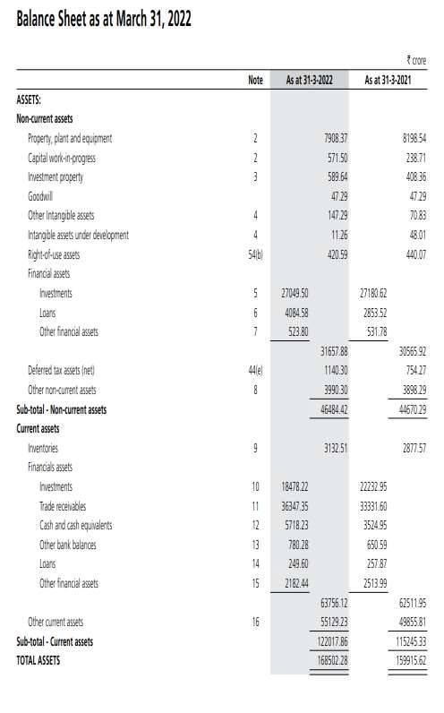

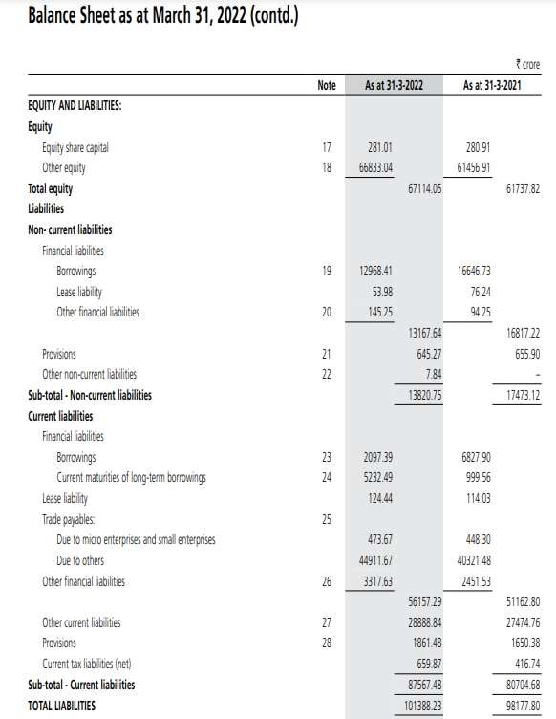

Ans 3a.
Introduction
Net working capital is the difference between a company's current liabilities and assets on its balance sheet. It is a measure of a firm's liquidity and capability to meet short-term duties in addition to funding the company's operations. The proper position is to have fewer current liabilities than present-day assets and thus have positive internet working capital stability.

Q3.b. With the following data, calculate DSO and Debtor Turnover Ratio. Explain the importance of each and make inferences. (5 Marks)
Rs. In Crores
 | FY 2021-22 | FY 2020-21
Sales | 1,01,000 | 87,255
Receivables | 36,347 | 33,331
0% of the sales are on credit basis

Ans 3b.
Introduction
Income great day, DSO measures the standard number of days a business takes to collect income payment. DSO is usually determined on an annual, quarterly, and monthly basis.2
To calculate DSO, divide the average accounts receivable throughout the required duration using the absolute value of income in credit during the exact length. Then multiply the

