FINANCIAL MANAGEMENT
December 2022 Examination

Q1. XYZ Ltd. is considering a proposal of installing a Machine. The equipment would involve a Cash outlay of Rs. 25,00,000. The expected life of the project is 5 years without any salvage value. Below cashflow will be achieved by the organization:

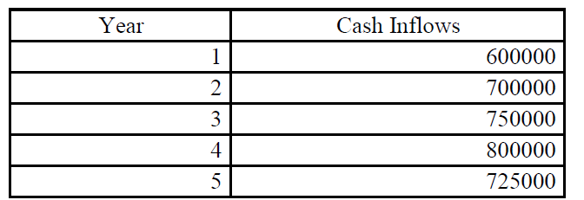
Discounting rate is 8%
Find out the PV of Cash Inflows, NPV, and Profitability Index
Answer no 1
PV(Present Value):
PV is the current worth of a future sum of money or stream of cash flows given a specified rate of return.
Future cash flows are discounted at the discount rate, and the higher the discount rate, the lower the present value of the future cash flows.
Determining the appropriate discount rate is the key to properly valuing future cash flows, whether they be earnings or obligations
It is only half solved

Buy Complete from our online store

https://nmimsassignment.com/online-buy-2/

NMIMS Fully solved assignment available for session December 2022,

your last date is 29th November 2022.

Lowest price guarantee with quality.
Charges INR 350 only per assignment. For more information you can get via mail or Whats app also
Mail id is aapkieducation@gmail.com

Our website www.aapkieducation.com
After mail, we will reply you instant or maximum
1 hour.
Otherwise you can also contact on our
whatsapp no 8791490301.
Contact no is +91 87-55555-879

Q2. The following particulars are available in respect of three investment proposals:
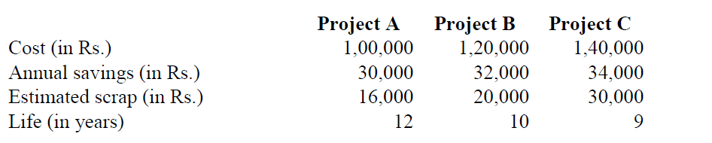
Taking interest rate to be 8% p.a. rank these proposals by using Net present value method and Profitability index method.

Answer no 2

A) Calculation of net present value (NPV):

NPV=Present value of future cash flow-Initial investment

In the given case, future cash flow consists of annual savings and scrap value. Annual savings is for each year over the life of the project and scrap represent the cash flow in last year of project.

Thus, present value of future cash flow is:

Q3. Being Working Capital Consultant, your client is planning to start a business related to FMCG sector and he is confused that how much working capital will be required to start his business and also he wants to know that why service industry requires less working capital, find out:
a. How to determine the working capital requirement of FMCG business. (5 Marks)
b. Why service industry requires less working capital as compare to manufacturing industry.
Answer no 3
A)
Working capital, also known as net working capital, is the difference between a company’s current assets, like cash, accounts receivable (customers’ unpaid bills) and inventories of raw materials and finished goods, and its current liabilities, like accounts payable.

working capital is defined as current assets over current liabilities, at the time of determination of working capital, quality of current assets especially size of debtors and inventory are

b)

The next factor to take into account when selecting working capital is the kind of business the company is involved in. Due to the short operating cycle, retail businesses and trading companies require less working capital.
Similar to the manufacturing sector, the service sector requires less working capital than the manufacturing sector.

