RESEARCH METHODOLOGY
December 2022 Examination

1. Develop a sample research proposal to represent the various steps of hypothetico- deductive method. (10 Marks)

Ans 1.

Introduction
Science depends upon numerous foundations that incorporate the processes of reasoning, logic, and values to perform research. Depending on the research methods, the research base is scientific reasoning. It fluctuates with several natures of standards and depends on four fundamental foundations pulling the concept of scientific reasoning completely. This job will present a research proposal providing various steps of the hypotheticodeductive method.
Aim
This research aims to prepare a research proposal demonstrating various steps of the

It is only half solved

Buy Complete from our online store

https://nmimsassignment.com/online-buy-2/

NMIMS Fully solved assignment available for session December 2022,

your last date is 29th November 2022.

Lowest price guarantee with quality.
Charges INR 299 only per assignment. For more information you can get via mail or Whats app also
Mail id is aapkieducation@gmail.com

Our website www.aapkieducation.com
After mail, we will reply you instant or maximum
1 hour.
Otherwise you can also contact on our
whatsapp no 8791490301.
Contact no is +91 87-55555-879

Q2. What is meant by a dependent variable? Identify the one from the following theoretical model. State any six hypotheses from this model. Identify the mediating variable.
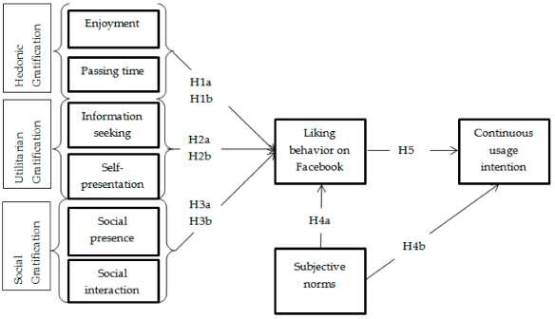

(10 Marks)

Ans 2.

Introduction
An organization is constantly searching for creating steps toward its organization. Running a service and ordering worth in the market is different. It isn't simple to step in advance with adequate financing for a business task, but things are pretty smooth for a currently established organization. The inquiry is why the action in the query is discussed about the variable, specifically the dependent variable. Although the matter is linked with the academic research task, it is also gotten in touch with the area experience. Without obtaining the lead in our hands,

3. Zomato was listed on 23 July 2021 on NSE at 126 INR which has toppled 46 INR on 30 July 2022. There has been a consistent decline in the revenue of Zomato and increase in losses. The customers have raised concerns on poor quality of delivery and extra prices charged by Zomato. The manager is interested in identifying issues related to customer and other stakeholders for decline in the trust in brand.

a. Develop a questionnaire to survey the consumer and collect their response on what factors might be responsible for decline in consumers satisfaction? (5 Marks )

Ans 3a.

Introduction

It has been observed that Zomato is dealing with a consistent decline in its revenue and a rise in losses. The consumers have complained about inadequate delivery top quality and the extra price billed by the company. Therefore, the manager expects to identify the problems linked to customers and other investors for the decline in brand reputation. This portion presents a study to

b. Identify some interview questions that you would use for deriving qualitative responses? Who will be ideal respondent for the interview? (5 Marks)

Ans 3b.

Introduction
Zomato top the business index ranking for company purpose and has been there for the last few years too, yet the social action is not in favor of the firm and is continually encountered. However, all the outside stakeholders are vital aspects. Still, to understand the altering strategy

