Financial Management
September 2022 Examination

Q1. A company issued 7,000, 7% debentures of Rs. 100 each par on 1.4.2017 to be matured on 31.3.2024. The debentures will be redeemed at a premium of 10% on maturity. COMPUTE the cost of debentures assuming 25% as tax rate.
Ans 1.
Redemption of Debentures is defined as the settlement of borrowed funds by a company or a firm to their debenture holders after the date of maturity. After the funds are repaid, the liability on the debenture account is discharged.
As per the Indian Companies Act of 1956, all companies who issue a debenture need to create

Buy Complete from our online store

https://nmimsassignment.com/online-buy-2/

NMIMS Fully solved assignment available for session September 2022,

your last date is 29th August 2022.

Lowest price guarantee with quality.
Charges INR 299 only per assignment. For more information you can get via mail or Whats app also
Mail id is aapkieducation@gmail.com

Our website www.aapkieducation.com
After mail, we will reply you instant or maximum
1 hour.
Otherwise you can also contact on our
whatsapp no 8791490301.
Contact no is +91 87-55555-879

Q2. Below is the capital structure of Chand Ltd and cost incurred by Chand Ltd. for the capital.
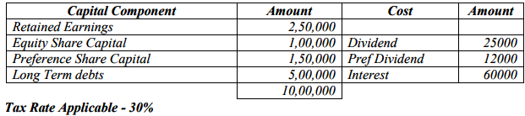
Tax Rate Applicable - 30%
Ans 2.
CALCULATION OF COST OF CAPITAL
(a) Cost of Equity Share capital (K_{e})
K_{e} = Amount of Dividend
Amount of Equity Share Capital
= 25,000 / 1,00,000

Q3. Solve the below given cases:
a. Calculate the Operating Cycle of Western Food Limited for the below given information:
Raw Material holding period (days) 30
WIP days 45 Finished good days 20
Debtor days 60 Creditor days 30
Ans 3a.
The operating cycle of a firm is the time duration between paying the creditors for inventory to collecting cash from credit sales. It is generally denoted by the number of days. The formula for the same is as

b. You won a lottery of Rs. 150000 from Dus ka dum and you have deposited the amount in bank and which is going to redeemed in 10 years, interest rate: 12%, find out what amount you will be receiving after 10 years.
Ans 3b.
This question needs to be solved using the Future value of money concept.

