**Business Statistics for Decision Making**

**September 2022 Examination**

**Q1. Solve the following questions (with necessary steps in word) and write the interpretation.**

**Snowfalls occur randomly and independently over the course of winter in a Manali city. The average is one snowfall every 3 days.**

**1. What is the probability of five snowfalls in 2 weeks?**

**2. Find the probability of a snowfall today? (10 Marks)**

**Ans 1.**

**Introduction**

Snowfalls naturally happen at random and independently during the winter in a city. Considering that there is typically one snowfall every three days as well Following that, the quantity of snowfalls (X) has a Poisson distribution with a mean of 1 every three days. The random variable's pmf is then provided by

P(X=x)= $\frac{e^{-u}u^{x}}{x!}$ For x=0,1,2,…..

1. It is given that the number of snow falls for 3 days is 1, the mean number of snow falls for 1day is 1/3

Buy Complete from our online store

<https://nmimsassignment.com/online-buy-2/>

NMIMS Fully solved assignment available for**session September 2022,**

your**last date is 29th August 2022**.

Lowest price guarantee with quality.

Charges**INR 299 only per assignment.**For more information you can get via mail or Whats app also

Mail id is [aapkieducation@gmail.com](mailto:aapkieducation@gmail.com)

Our website [www.aapkieducation.com](http://www.aapkieducation.com/)

After mail, we will reply you instant or maximum

1 hour.

Otherwise you can also contact on our

whatsapp no 8791490301.

Contact no is +91 87-55555-879

**Q2. From the Following data on Yearly subscription of GTPS Broadband, calculate the forecasted value of 2016 using 5-Year moving Average. (10 Marks)**

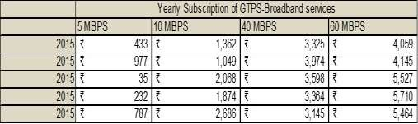

**Ans 2.**

**Introduction**

A moving average is a method used in statistics to examine data points by averaging a number of different subsets of the entire data set. A moving average (MA) is a stock indicator used frequently in technical analysis in the world of finance.

**Q3a. The following data represent the number of appointments made per 15-minute interval by telephone solicitation for a lawn-care company namely ‘Amarjeet Finance’. Assume these are population data. (5 Marks)**

**1) Calculate the variance.**

**2) Calculate the standard deviation.**

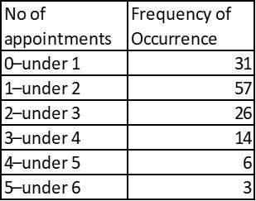

**Ans 3a.**

**Introduction**

In order to determine the appropriate asset allocation, variance is used in finance to analyze the relative performance of each asset in a portfolio. The standard deviation is equal to the variance squared.

The term "standard deviation" (or "") refers to a measurement of the data's dispersion from the

**Q3b. From the following Figure Calculate Cost of Living Index (aggregate expenditure method). (5 Marks)**

**TABLE BELOW**

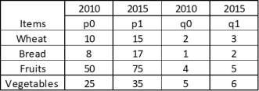

**Ans 3b.**

**Introduction**

The weights used in this method are the amounts of various commodities consumed by a certain group of people in the base year. The overall cost of each commodity for each year is then determined. To do this, multiply the current year's price by the quantity or weight from the base