Decision Analysis & Modeling
June 2022 Examination

Q1. XYZ co ltd has taken up a special project consisting of 8 activities whose three-point time estimates are listed in the table below. Activities are marked with their node numbers.
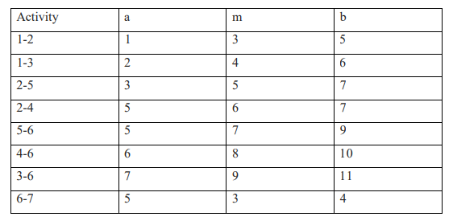
a. Find the expected time and standard deviation for each activity?
b. What is the probability that project will be completed in 21 weeks?
c. If a project manager gives an assurance of 99% in how many days the project would be completed? (10 Marks)
Answer 1:
Introduction
Management used various techniques to calculate the probability of results. Three-point estimating is one such management method. This estimating technique takes into consideration three various cases while computing the probability, namely -the best case ( i.e., the moment shown is most favorable), one of the most potential case( i.e., the moment illustrated is most possible), and the worst-case( i.e., the moment portrayed is most downhearted).
The triangular circulation model can be used to calculate a three-point estimate. The estimation is simple. The three cases of estimating strategies, i.e., confident (O), probable (M) the
Its Half solved only
Buy Complete from our online store

https://nmimsassignment.com/online-buy-2/

NMIMS Fully solved assignment available for session June 2022,

your last date is 29th May 2022.
Lowest price guarantee with quality.
Charges INR 299 only per assignment. For more information you can get via mail or Whats app also
Mail id is aapkieducation@gmail.com

Our website www.aapkieducation.com
After mail, we will reply you instant or maximum
1 hour.
Otherwise you can also contact on our
whatsapp no 8791490301.
Contact no is +91 87-55555-879

Q2. Using graphical method find strategy for Player A, Player B and value of the game.

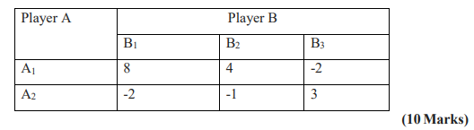
Answer 2: The strategies of player A & B and the value of the game have to be calculated using the graphical method.
Introduction
The graphical technique in game theory is a strategy for obtaining the players' strategy values and the game's worth. The likelihood worth’s are shown on a bar graph. After plotting the factors, the variety of junctions in the chart is evaluated. If the number of crossways below the maximin is 2 x 2, then the players' strategies and the value of the game are calculated. According to the game theory, the methods can be calculated in 2 kinds using the graphical approach

Q3. Answer the following question
a. What are the uses of slack and surplus in solving the linear programming problem? (5 Marks)
Answer 3a – Uses of slack and surplus in solving the linear programming problem
Introduction
Linear programming is additionally prominent as linear optimization. It is a technique used to calculate the readily available, most acceptable result by representing variables in a model about maths. These variables depict linear partnerships. Linear programming entails estimating

b. Discuss the relationship of MODI Method with the concept of Duality? (5 Marks)
Answer 3b:
Relationship between the MODI concept and the Duality concept
Introduction
The duality concept concentrates on two different methods of adjusting a restraint in a straight show's trouble. MODI method is the best method to compute the chance expense of transport. The abbreviation MODI can be increased right into a revised circulation method. Though both

