Advanced Financial Accounting
June 2022 Examination

Q1. A, B and C were partners sharing profits in the ratio of 5: 4: 3. They decided to change their profit sharing ratio to 2:2:1 w.e.f. 1st April, 2019. On that date, there was a balance of ₹ 3, 00,000 in General Reserve and a debit balance of ₹ 4,80,000 in the Profit and Loss Account. Pass necessary journal entries for the above on account of change in the profit-sharing ratio. (10 Marks)
SOLUTION:
Introduction:
A partnership is a felony shape of business whereby extra people agree to share the income and liabilities. In India, the partnership is governed by the Indian Partnership Act, 1932. The association partners can also decide to go right into a written partnership agreement or the partnership deed, which enlists the numerous clauses that may govern the partnership from its inception to its end if it takes place. The events of a partnership association may be people,
Its Half solved only
Buy Complete from our online store

https://nmimsassignment.com/online-buy-2/

NMIMS Fully solved assignment available for session June 2022,

your last date is 29th May 2022.
Lowest price guarantee with quality.
Charges INR 299 only per assignment. For more information you can get via mail or Whats app also
Mail id is aapkieducation@gmail.com

Our website www.aapkieducation.com
After mail, we will reply you instant or maximum
1 hour.
Otherwise you can also contact on our
whatsapp no 8791490301.
Contact no is +91 87-55555-879

Q2. Hari and Krishan were partners sharing profits and losses in the ratio of 2: 1. They admitted Shyam as a partner for 1/5th share in the profit. For this purpose, the Goodwill of the firm was to be value on the basis of three years’ purchase of last five years’ average profits. The profits for the last five years were:
Calculate Goodwill of the firm after adjusting the following:
The profit of 2014-15 was calculated after charging ₹ 10,000 for abnormal loss of goods by fire. (10 Marks)
SOLUTION:
Introduction:
A company's fixed assets may be divided into tangible and intangible assets. The tangible assets of the business are the assets with physical existence. These consist of property like land, buildings, furniture, etc. some examples of intangible property are goodwill, brands, patents, etc. Goodwill is one of the greatest common intangible assets discovered on a company's balance. The goodwill of the business can be defined as the business's popularity. It's far an intangible

Q3.a. Hanif and Jubed were partners in a firm sharing profits in the ratio of their capitals. On 31st March, 2013 their balance sheet was as follows:
PLEASE CHECK THE TABLE BELOW
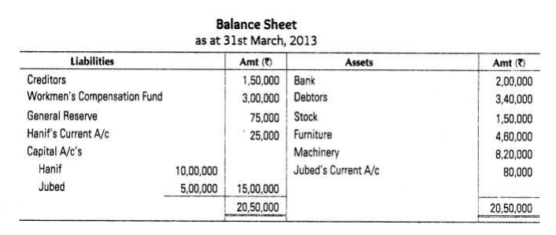
On the above date the firm was dissolved
(i)Debtors were realized at a discount of 5%, 50% of the stock was taken over by Hanif at 10% less than the book value. Remaining stock was sold for Rs 65,000.
(ii)Furniture was taken over by Jubed for Rs 1,35,000. Machinery was sold as scrap for Rs 74,000.
(iii)Creditors were paid in full.
(iv)Expenses on realization Rs 8,000 were paid by Hanif. Prepare realisation account. (5 Marks) –
SOLUTION:
Introduction:
Once formed, the companions intend to carry on the enterprise for all time. But, some situations may arise beneath which it can be required to dissolve the partnership business. Dissolution marks the quit of a partnership or the partnership firm. The firm's dissolution occurs when the

Q3.b. X, Y and Z were partners sharing profits in the ratio of 1/2, 3/10, and 1/5. X retired from the firm. Calculate the gaining ratio of the remaining partners. (5 Marks)
Introduction:
A partnership is a business shape between or extra persons ruled by the Indian Partnership Act, 1932. A partnership agreement is a written settlement among the partners of a legally binding partnership company. It is also referred to as a partnership deed. The partnership agreement defines the applicable clauses on the

