Operations Research

April 2022 Examination

1. Consider the transportation problem presented in the following table:
TABLE BELOW
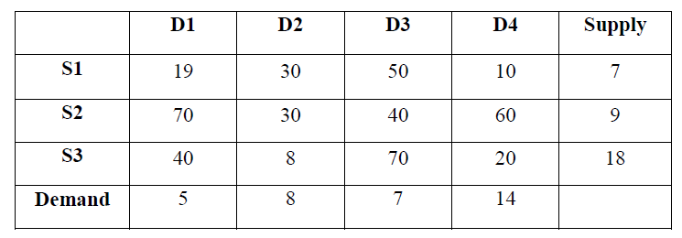

Find initial feasible solution using Vogel's Approximation method (VAM), also find
Optimal solution using stepping-stone method. (10 Marks)
Solution:
Introduction:
Vogel’s approximation method is used to get an initial feasible solution in a transportation problem. It works on the concept of opportunity or Penalty cost.
Concept and application:
The problem is balanced TP as the total supply equals overall demand. So, we will now find a feasible solution to this transportation problem.
Its Half solved only
Buy Complete from our online store

https://nmimsassignment.com/online-buy-2/

NMIMS Fully solved assignment available for session April 2022,

your last date is 25th March 2022.
Lowest price guarantee with quality.
Charges INR 299 only per assignment. For more information you can get via mail or Whats app also
Mail id is aapkieducation@gmail.com

Our website www.aapkieducation.com
After mail, we will reply you instant or maximum
1 hour.
Otherwise you can also contact on our
whatsapp no 8791490301.
Contact no is +91 87-55555-879

2. Consider the transportation problem with plant source and warehouse distribution presented in the following table:
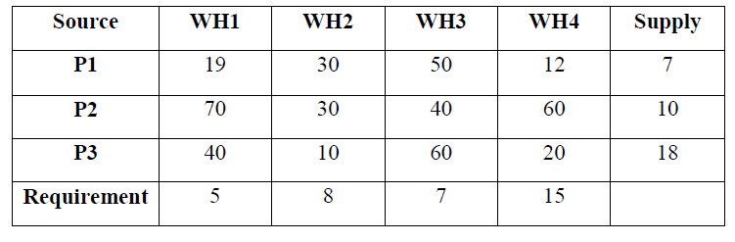
Find initial feasible solution using Northwest corner method and Least cost method, also find optimal solution using Modified Distribution (MODI) method. (10 Marks)
Solution:
Introduction:
Operating costing is an extended and delicate form of process costing. One of the areas where operating costing is used is the transportation problems. Depending on demand and supply variables, a transportation problem may be a balanced hassle or an imbalanced one. TO gain a feasible way to a transportation hassle, several techniques are used. The Northwest nook method is one of them.

3. A small project consisting of eight activities has the following characteristics:
TABLE BELOW
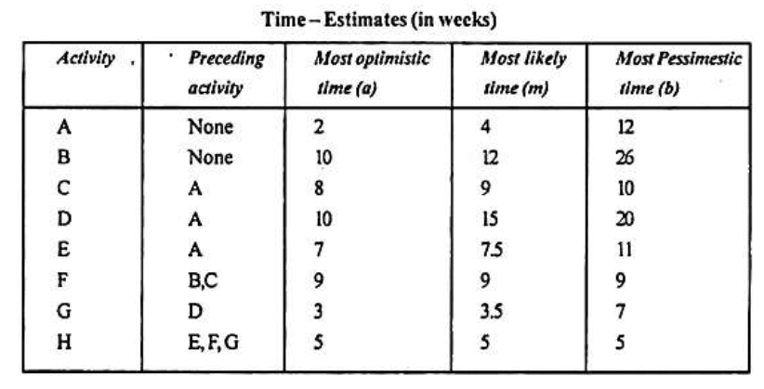
a. Draw the PERT network for the project.
Prepare the activity schedule for the project.
Determine the critical path. (5 Marks)
Solution:
Introduction:
A network represents various links between the objects, which shows the flow of a sequence of defined events and activities. There are various strategies for showing network models. CPM and PERT are excellent methods of displaying progress, completing large and complicated projects,

b. If a 30- week deadline is imposed, what is the probability that the project will be finished within the time limit?
If the project manager wants to 99% sure that the project is completed on the schedule date, how many weeks before that date should he start the project work?
(5 Marks)
Introduction:
Under PERT/ CPM, a network is drawn using boxes, circles, and arrows. Boxes and circles represent the description of the activity, and the arrows are drawn to display the relationships among the activities. It is used to sequence the activities and track the progress of the activity at

