Macro Economics

April 2022 Examination

Q1. Explain the Basic Equation of National Income with its genesis meaning (10 Marks)
Ans 1.
Introduction:
In any economy, we repeatedly see the terms GDP and GNP. Those are nothing, however, variables or factors of calculating national income. They picture the national income of any country in a given financial year. In simple terms, national profits refer to the entire monetary value of all the goods and services produced in an economy in a single financial year. We also can say that it is the sum of all issue income generated in an economy in a financial year.
Its Half solved only
Buy Complete from our online store

https://nmimsassignment.com/online-buy-2/

NMIMS Fully solved assignment available for session April 2022,

your last date is 25th March 2022.
Lowest price guarantee with quality.
Charges INR 299 only per assignment. For more information you can get via mail or Whats app also
Mail id is aapkieducation@gmail.com

Our website www.aapkieducation.com
After mail, we will reply you instant or maximum
1 hour.
Otherwise you can also contact on our
whatsapp no 8791490301.
Contact no is +91 87-55555-879

Q2. Explain J M Keynes Criticism on Classical Theories of Macro Economics – Imp Points (10 Marks)
Ans 2.
Introduction:
Many theories talk about the nature and essence of macroeconomics. The two which have been widely spoken are classical and non-classical theory. Classical economists think that the economy is self-regulating in approach. It will modify in line with the desires themselves and reach the actual GDP level. They accept that the economy can always acquire the natural level of GDP or actual GDP. They say that real GDP is attained by entirely using all the available

Q3.a. You are given the following data. Calculate GNP and GDP at factor cost. (5 Marks)
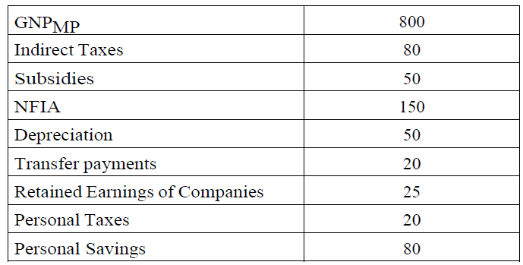
Ans 3a.
Introduction:
There are three different methods of calculating national income. Those three strategies are to be used with very safe hands and patiently. There are various precautions connected to these strategies; for, e.g., inside the detail of double counting, inside the case of the cost-added technique, you must deduct the intermediate consumption. Else, it might be calculated two times,

Q3.b. Explain the Demand Pull Inflation with example (5 Marks)
Ans 3b.
Introduction:
Demand-pull inflation is also referred to as rate inflation. It's miles while any goods or services' combined demand outstrips the aggregate deliver. It's miles, particularly an impact of the rise in patron demand. Because of growth in demand, providers attempt to grow supply, and when additional delivery is unavailable, dealers increase their prices, referred to as demand-pull

