NMIMS Global Access
School for Continuing Education (NGA-SCE)
Course: Employability Skills - II Tally
Internal Assignment Applicable for April 2022 Examination

Q.NO. 1 Please create a company in tally using following mention Details?
Company Name: - Zen Foundation.

Primary Mailing Details.
Mailing Name: - Zen Foundation.
Address: - Western Express Highway, Andheri (East), Mumbai.
Country: - India
State: - Maharashtra.
Pin Code: - 400 099.

Contact Details.
Phone No.: - 022-224466
Mobile No.: - 99000 00000
Fax No.: -
E-mail: - z@gmail.com
Website:-

Books & Financial Year Details.
Financial Year Begins from: - 1-4-2020
Books Beginning from: - 1-4-2020

Security Control.
Use Security Control: - No

Base Currency Information.
Base Currency symbol: - Rs.
Formal Name: - INR
Suffix Symbol to Amount: - No
Add Space between Amt & Symbol: - Yes
Show Amount in Millions: - No.
Number of Decimal Places: - 2
Word Representing amount after Decimal: - Paise
Number of Decimal Places for Amt in Words: - 2

Answer:

ANS:- these steps following in this process , create a company in tally software .
- Click and open tally software, and press key Alt+f2.
- Go to company information and click tag new company.
- All information fill up steps by steps and after that pass entry to accepts through by Enter.
After 3 step open a gateway of Its Half solved only
Buy Complete from our online store

https://nmimsassignment.com/online-buy-2/

NMIMS Fully solved assignment available for session April 2022,

your last date is 25th March 2022.
Lowest price guarantee with quality.
Charges INR 199 only per assignment. For more information you can get via mail or Whats app also
Mail id is aapkieducation@gmail.com

Our website www.aapkieducation.com
After mail, we will reply you instant or maximum
1 hour.
Otherwise you can also contact on our
whatsapp no 8791490301.
Contact no is +91 87-55555-879

Q.NO. 2 Please find out following numbers and Ratios from provide tally backup for the financial year 2020-21 & 2021-2022
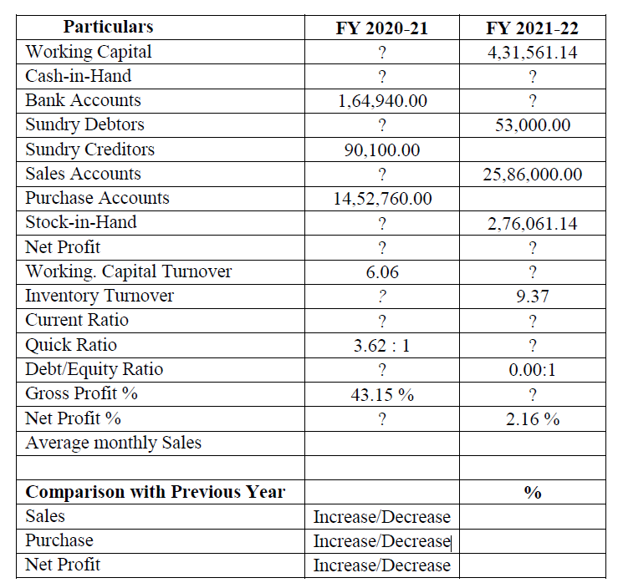
https://studentzonengasce.
nmims.edu/assignments/Sep2021/Assignment%20Sep%20Batch%20Tally%20backup.rar
ANS:-these are finding these numbers and ratios through work in tally software . This sheet convert tally to excel sheets.

Q.NO:- 3 ledger creation and Accounting Entries in tally.

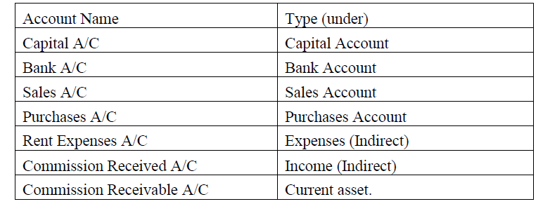
ANS:-A) create a ledgers and accounts in tally in Zen Foundation.

B) Passes the entries in Zen Foundation.
1. Capital Introduced in organization in Bank Rs. 1,20,000/- & in Cash Rs. 30,000/- on 1st
April 2020.
2. Cash Deposited in bank on 2nd April 2020 Rs. 15,000/-.
3. Cash purchase of Rs. 40,000/- on 1st May 2020. (Paid from Bank)
4. Cash Sales of Rs. 30,000/- on 31st May 2020. (Received in bank)
5. Rent Paid Rs. 10,000/- by Cheque on 2nd June 2020.
6. Cash withdrawn from Bank Rs. 10,000/- on 2nd August 2020.
7. Debit Note Sent to Supplier for Rs. 2,000/- on 1st Oct 2020.
8. Debit Note Received from customer for Rs. 3,000/- on 1st Nov 2020. (To be enter in
Credit Note.)
Ans

