Employee Development and Talent Management
April 2022 Examination

Q1. Keyuri wants her organization to focus on potential appraisals. What could be the
reasons for carrying out potential appraisals? What techniques can her organization
consider for potential appraisal?
Ans 1.
Introduction:
Keyuri would like her company to concentrate on her appraisals potential The potential appraisal refers to the appraisal that involves the identification of the hidden talents and abilities of an individual. The individual may or may not know about them. Potential appraisal is a forward-looking appraisal that's primary goal is to determine and assess the ability of employees to take on higher positions and responsibilities within the organizational hierarchy Its Half solved only
Buy Complete from our online store

https://nmimsassignment.com/online-buy-2/

NMIMS Fully solved assignment available for session April 2022,

your last date is 25th March 2022.
Lowest price guarantee with quality.
Charges INR 199 only per assignment. For more information you can get via mail or Whats app also
Mail id is aapkieducation@gmail.com

Our website www.aapkieducation.com
After mail, we will reply you instant or maximum
1 hour.
Otherwise you can also contact on our
whatsapp no 8791490301.
Contact no is +91 87-55555-879

Q2. Progressive companies ensure that the employee development climate in the organization is well created and sustained. Enlist the factors that contribute to employee
development climate.
Ans 2.
Introduction:
The process of employee development consists that aims to improve employees' current capabilities and abilities and forming new ones that can help the company's objectives.
The core of this definition are the following finer aspects of importance:
It's not just about creating strategies for organizational L&D strategies.

Q3a. Define Process of Career Planning. Enlist the Merits and Demerits of Career Planning.
Ans 3a.
Introduction
The process for career Planning: Career Planning is the process by which an individual is focused on where they want to be in the future and is also known as self-evaluation. A proper plan is made by an individual to ensure an effective career path their lives. Planning is an ongoing process. It is essential to continue thinking about their career each time. They must

3.b. What is on-the-job training? How is coaching different from mentoring.
Ans 3b.
Introduction
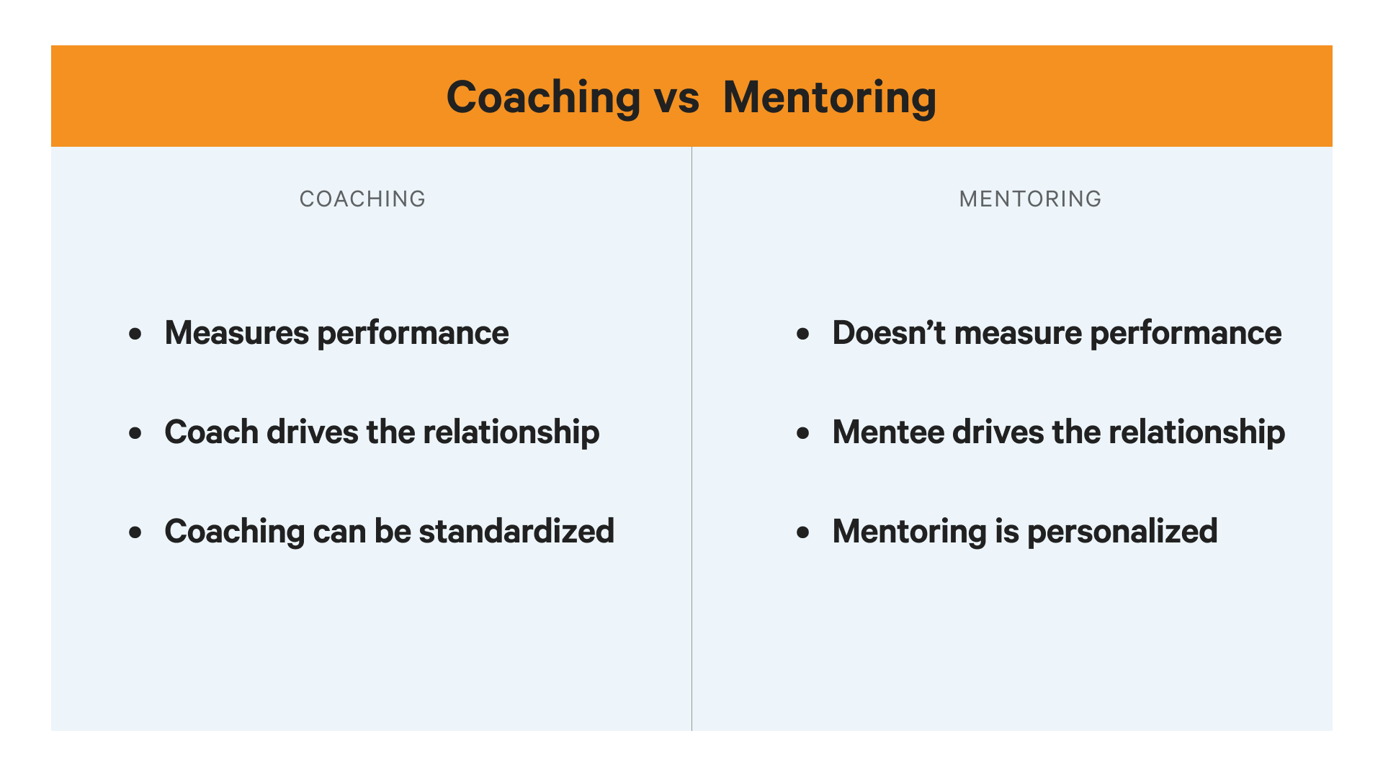
What is a Coach?: Coaches are concerned about an individual's performance in particular activities. They observe you as you work on specific abilities and identify areas where you can improve. They will provide feedback then practice again and repeat the procedure. The concept

