Business Statistics for Decision Making

April 2022 Examination

Q1. A health scientist has created three different diet plans for a weight loss program. He conducted an experiment with 24 volunteers to see the impact on weight loss. He measured the weights of the volunteers before the start of the diet plan. Then they were assigned to one specific diet plan for a month. After one month their weights were measured again. The differences in weights are given in the table below for each of the diet plans. At the end of the experiment, the scientist wanted to understand if there is a significant difference in weight loss among the volunteers of the three diet plans. Read the data table below and answer the questions.
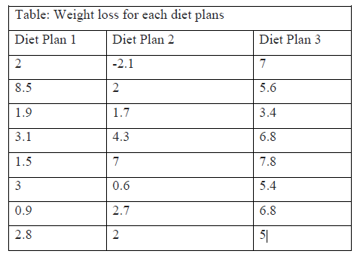
a. Conduct ANOVA on the above table. Do you find a significant difference in weight loss due to the three diet plans? Explain and interpret using both the p-value and F critical value from the output. Use MS-Excel for the analysis.
b. Why do you think ANOVA is required to answer this question?
c. What is the formula to calculate F-ratio? (Only write the formula. You do not need to show the calculations for F-ratio). (10 Marks)
Ans 1.
Introduction:
ANOVA: ANOVA or analysis of Variance becomes evolved through Ronald Fisher. There are two approaches to calculating ANOVA: one-way analysis of Variance and one-way evaluation of Variance. The only-manner analysis of Variance helps a man or woman recognize the statistical difference among the suggests of 3 or greater than three unbiased businesses. The only reasons for using analysis of Variance are checking out specific speculation, know-how the reaction of different groups, etc. but, the two-manner analysis of variance includes independent

Its Half solved only
Buy Complete from our online store

https://nmimsassignment.com/online-buy-2/

NMIMS Fully solved assignment available for session April 2022,

your last date is 25th March 2022.
Lowest price guarantee with quality.
Charges INR 299 only per assignment. For more information you can get via mail or Whats app also
Mail id is aapkieducation@gmail.com

Our website www.aapkieducation.com
After mail, we will reply you instant or maximum
1 hour.
Otherwise you can also contact on our
whatsapp no 8791490301.
Contact no is +91 87-55555-879

Q2. Consider the following sample. It contains the weights of 25 participants:
55, 57, 58, 43, 62, 67, 71, 69, 66, 51, 72, 62.5, 58.5, 61, 72.5, 75, 44, 48, 49, 49.5, 49,
62, 66, 71, 58. Calculate and plot the following using MS-Excel. Write the formula and show the steps.
a. Variance
b. Standard deviation
c. Histogram
d. Ogive
Note: For histogram and ogive use bins numbers as 40, 45, 50, 55, 60, 65, 70 (10 Marks)

Ans 2.
Introduction:
Variance: Variance helps one in the size of the space of each variable of a statistics set from its suggested or average price. Buyers and finance experts find variance a precious tool for the choice-making process and evaluating various aspects. In simple phrases, variance calculates the deviation inside the set.
Standard Deviation: Fashionable deviation is the square root of variance. The variance of a data set gives a rough concept about the distance or unfold of a variable from it’s imply. But, standard

Q3. You have been hired as a researcher for a prominent research-based organization and you have been allocated a new project for helping out a client. You know that the time taken to complete similar projects is normally distributed with a mean of 50 days and a standard deviation of 4 days.
a. What is the probability of finishing this project within 45 – 55 days? (5 Marks) –

Ans 3a.
Introduction:
Normal Distribution: It is a distribution with a symmetrical bell-fashioned curve and is the appropriate model for measurement distributions going on in exercise in unique conditions’ colossal range. The normal distribution also provides a person a terrific approximate to unique other distributions such as Binomial distribution, Poisson distribution, and many others. It also presents a terrific model of various information for the sampling distribution.

b. When do we use Poisson distribution? Give two example scenarios. (5 Marks) –
Ans 3b.
Introduction:
Poisson distribution is a distribution modeling the number of events occurring in a specific time interval when the events are occurring one after any other in time and in a properly-defined way. The well-defined manner presumes that the occasions are happening singly at a steady rate, and the events going on in individual time intervals are independent of each other.

