Research Methodology
April 2022 Examination

Q1. The central bank of a country is exploring options to boost the economic activities post COVID. They are thinking to change the various interest rates to motivate investments and economic transactions. However, they are not sure whether this would yield the desired results. The research team in the bank have come up with a set of hypotheses and they are confident of conducting a research and finding the outcome. Answer the following questions:

What is hypothesis testing in research? Write the steps which is followed for the same. Include details of null and alternate hypothesis in your answer. (10 Marks)

Ans 1.

Introduction
Worldwide the justification of funding deficits through corporate banking differs significantly among nations. For instance, in the United States, extra than enough financing has been diverted to savings resulting in a monetary recession. A statistical hypothesis is how the researcher can test an assertion about sample records. The government should start with the more excellent price range for emergency epidemic use, such as solid clinical desires such as building take a look at laboratories and emergency scientific rooms. The usage of various pattern analyses,
Its Half solved only
Buy Complete from our online store

https://nmimsassignment.com/online-buy-2/

NMIMS Fully solved assignment available for session April 2022,

your last date is 25th March 2022.
Lowest price guarantee with quality.
Charges INR 199 only per assignment. For more information you can get via mail or Whats app also
Mail id is aapkieducation@gmail.com

Our website www.aapkieducation.com
After mail, we will reply you instant or maximum
1 hour.
Otherwise you can also contact on our
whatsapp no 8791490301.
Contact no is +91 87-55555-879

Q2. While going through a research paper in a leading journal you have came across the following model comprising multiple variables:
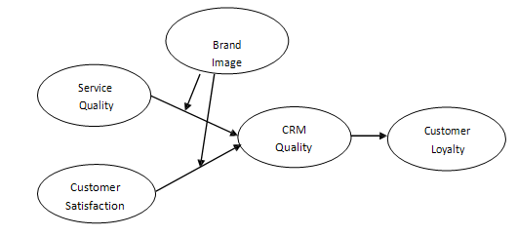

Answer the following questions:

What is meant by ‘variables’ in research? Identify and describe the following: dependent variable, independent variable, mediating variable and moderating variable. (10 Marks)

Ans 2.

Introduction
A variable in a file is essentially an individual, location, item, or phenomenon attempting to qualify in some manner. Covid-19 has affected several economic institutes which faced significant losses because of its recession. The length of the profile of the stock of international loans or rights and their forms. This, along with the notion that hobby costs are nearly zero and

Q3. A major FMCG company headquartered in Mumbai, is planning to diversify its product portfolio. As part of the attempt, they have decided to launch a new product which is more of an ayurvedic variant of one of their famous oral hygiene brands. The research and development team have already come up with the composition and orders have been placed for manufacturing of the units. However, the managers are still not clear whether they should launch the product in western India first or it should be launched nationwide at the same time. You as a research consultant have been hired to look into the case. You have decided to use the hypothetico-deductive method to arrive at the conclusions.
a. Identify and explain the broad problem area. (5 Marks)
b. How would you like to proceed further? (5 Marks)

Ans 3A.

Introduction
Science is built on several foundations that work collectively to give ways of thinking, reasoning, and morals for doing research. The cornerstone of all research is legitimate common sense, which relies upon the research methodology. It varies depending on the character of the profession and is built on several foundations.

Ans 3B.
Introduction
As a studies consultant of the reputed FMCG organization, it is higher to release the product worldwide because human beings will gain from an ayurvedic product. It's also going to create awareness about its uses and advantages worldwide. Thus it needs to be launched nationally to

