IT Infrastructure Management
April 2022 Examination

Q1. Select any three companies in different industries such as banking, retail store, airlines or package delivery that you do business with? How optimal IT Infrastructure in each company use to engage customer, keep the customer informed or create a unique customer experience? (10 Marks)

Answer 1.

Introduction
The three companies of various industries, banking, retail save, and package transport, wherein the IT infrastructure control entices the customers and retains the customers informed, will be discussed inside the next component. The businesses chosen for in addition discussion are HDFC bank for the banking sector, IKEA for the retail shop sector, and Amazon for the package deal delivery quarter. The facts generation infrastructure management of those groups has enhanced a few factors which are helpful for consumer engagement, and in addition, they're running greater
Its Half solved only
Buy Complete from our online store

https://nmimsassignment.com/online-buy-2/

NMIMS Fully solved assignment available for session April 2022,

your last date is 25th March 2022.
Lowest price guarantee with quality.
Charges INR 199 only per assignment. For more information you can get via mail or Whats app also
Mail id is aapkieducation@gmail.com

Our website www.aapkieducation.com
After mail, we will reply you instant or maximum
1 hour.
Otherwise you can also contact on our
whatsapp no 8791490301.
Contact no is +91 87-55555-879

Q2. For a hypothetical organization of selected industry suggest what all optimal IT Infrastructure is required for the rapid growth of the organization. Discussion should contain topics related to server farms, cloud computing, green computing and virtualization along with following components of IT Infrastructure Ecosystem. Propose a suitable IT Infrastructure: (10 Marks)

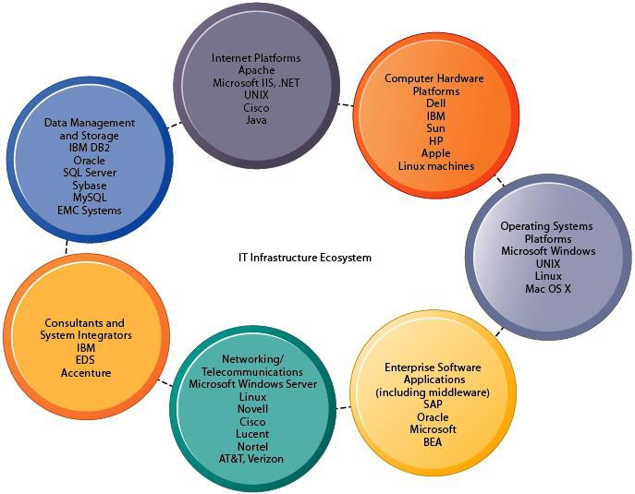

Answer 2.

Introduction
An international organization into hospitality coined as Synopsis Pvt Ltd has launched recently and is doing enterprise at a significantly high degree. The employer has done two Mergers after its launch with the corporations who provide items related to their enterprise. The company desires to have the most excellent IT infrastructure to achieve its business proposals. The employer can enhance through introducing new IT methods in its business and development. The IT infrastructure will help them perform the paintings quickly and on time. As they're into

Q3.a. In general hotel industry is not regarded as the most high-tech industry, and many hotels companies only cautiously adopt IT Infrastructure and new technologies. As for many guests, the quality of a hotel stay is in the end determined by whether or not they have some chocolates on their pillow at night and whether they get good night’s sleep and a good breakfast. For Modern, the hotel that defined 5000 instances in which a service encounter can lead to guest dissatisfaction, making the guests’ stay as enjoyable as possible is the most important goal. Offering technological advantages such as self- service check-in kiosks would not be considered appropriate for luxury hotels of this class. On the other hand, tasks that happen “behind the scenes” offer a host of opportunities to use information technologies. One of these applications is Modern’s customer relationship database. Containing records more than 2.5 million guests, this system is designed to store even the most minute guest preference, so that the guest’s next stay can be made even more enjoyable. In addition to information about guest’s favorite newspaper, or preference of room or pillow, even information overheard in a guest’s casual conversation with waiter is entered into database, so a guest who mentions that She/he likes a certain kind of flower might find a vase with bouquet of these on her/his table the next time she/he visits a Modern.
Question. What are the various components of IT infrastructure ecosystem used in the above caselet for achieving rapid growth in the selected industry? How cloud computing will be helpful in the industry discussed in the above caselet? How asset management is done in such kind of industry? (5 Marks)

3.b. Green computing is a practice of using computing devices so that they can be used efficiently and without causing harm to human beings and environment. The purpose of promoting green computing is to reduce the consumption of energy and to reduce carbon emission (CO2 emission). Suggest few actionable points/ drivers for achieving green data centres and servers. List down few features of green data centres and servers. What are various approaches used for green computing? Explain with the help of real life example. (5 Marks)

Answer 3(a).

Introduction
The use of modern technology is one of the main things executed by using modern hotels. The usage of the technology enables within the system of ensuring that the visitors have a great and at ease stay and ensures that they're given the most advanced treatment in phrases of technological advancement.

Answer 3b.
Introduction
the world is going via various environment-related issues nowadays. As a result, companies are adopting the green techniques of doing enterprise amongst all of the processes of the green information centers. These centers are usually built in an environment-pleasant region or facility.

