Micro Economics

1. Define Diminishing Marginal Return and fill the below table.
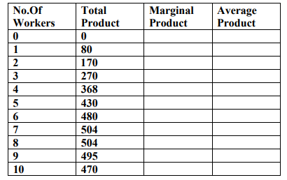
Answer:
INTRODUCTION:

Average Product: The total output of a product manufactured by a firm per unit of the employed factor is the average product. Generally, as an organization employs more units of the factor into the production process of a commodity, the average product of the commodity first increases and then falls. Therefore, usually, the average product curve is inverted U-shape. We can calculate the Its Half solved only

Buy full from our online store

https://nmimsassignment.com/online-buy-2/

NMIMS Fully solved assignment available for session June 2021,

your last date is 28th May 2021.

Lowest price guarantee with quality.

Charges INR 199 only per assignment. For more information you can get via mail or Whats app also
Mail id is aapkieducation@gmail.com

Our website www.aapkieducation.com

After mail, we will reply you instant or maximum

1 hour.

Otherwise you can also contact on our

whatsapp no 8791490301.
Contact no is +91 87-55555-879
2. Explain the demand schedule and enumerate individual and the market demand schedule. Calculate the market schedule from the given table: (10 Marks)
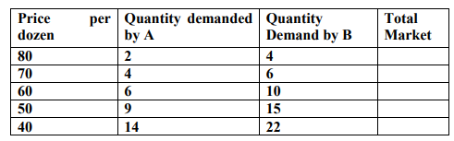
Answer:
INTRODUCTION:
Demand schedule: It is a table showing the quantity demanded at a different price level of a good or service. One can present the graphical representation of the demand schedule by showing price levels at the Y-axis and demand for the goods or services at X-axis. The table of demand schedule consists of a price list in either ascending or descending order, and the quantity demanded of the goods or

3.a. Enumerate elasticity of demand and explain the various types of price elasticity of demand (5 Marks)
Answer:
INTRODUCTION:
Elasticity of demand: Elasticity of demand is the change in demand of a commodity due to the change factors affecting the demand of a commodity. The factors affecting the demand of a commodity can be the product's price, the consumer's income, price of substitute (complementary and supplementary goods), and taste and preference of the consumer.
CONCEPT AND APPLICATION:
There are three kinds of

