Research methodology
Dec 2020

1. You have been asked to justify the use of mixed method in your upcoming research project. How will you justify it? What would you specify as its downside?

Answer: Research
Research in ordinary man’s language refers to “search for knowledge”. It can also be defined as an “art of scientific investigation”. It is also a systematic design, compilation analysis and the reporting the findings and solutions for the marketing problems of a company. The purpose of research is to find out the answers to questions through the application of systems and scientific ways. Though there is a specific purpose behind each research study, the purpose in general can be
a) Research remotes better decision making.
b) Research is the basis for innovation.
c) Research identifies the problem areas.
d) Research helps in forecasting, which is very important for managers.
e) Research helps in formulation of poli

2. What is meant by a dependent variable? Identify the one from the following theoretical model. State any six hypotheses from this model. Identify any two mediating variables.

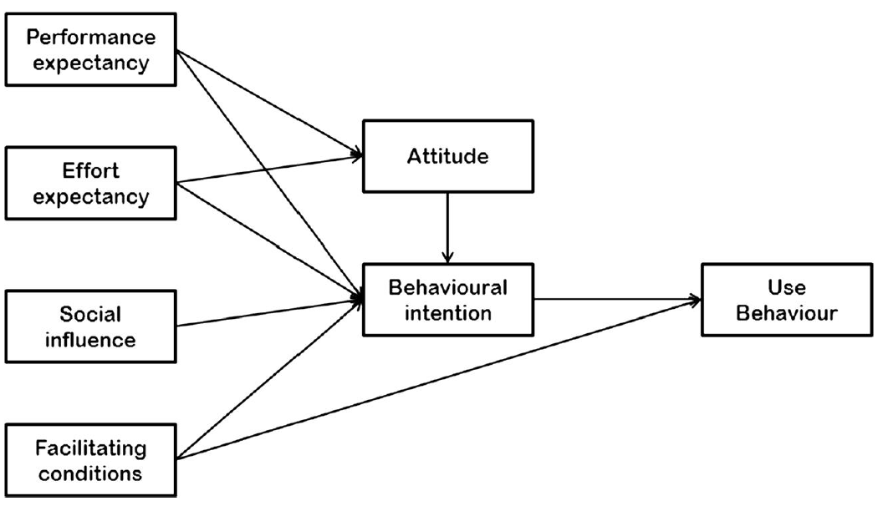

Answer: Dependent variable: The most important variable to be studied and analysed in research study is the effect-dependent variable (DV). The entire research process is involved in either describing this variable or investigating the probable causes of the observed effect. Thus, this in essence has to be a measurable variable. For example, in the organic food study, the consumer’s purchase intentions as well as sales of organic food products in the domestic market, could serve as the dependent variable.

In this model, all the

3. “I think we should conduct lab experiment instead of field experiment. We have got a limited budget. With such budget, conducting field experiment is not possible. Let's not even discuss about it." Pranav was quite frustrated with the recent cut in the budget of their research project. "Relax Pravin!" Dr Santosh Mahajani tried to pacify Pravin. "Don't compromise on the research methodology just because the budget has got reduced. We will need to make a decision based on what we need to achieve instead of what budget we have".
a. In what circumstances, Pranav should choose field experiment? What he should do to accommodate the recent budget cut?
b. In what circumstances, Pranav should choose lab experiment? What he should do to accommodate the recent budget cut?

Answer: a) Research methodology refers to the procedures used in making systematic observations or otherwise obtaining data, evidence, or information as part of a research project or study. It defines what the activity of research is, how to proceed, how to measure progress, and what constitutes success. Research helps in decision making, especially in business. Effective decisions lead to managerial success, and this requires reducing the element of risk and uncertainty.

When to use field experiment
There are two types of

