Business Statistics
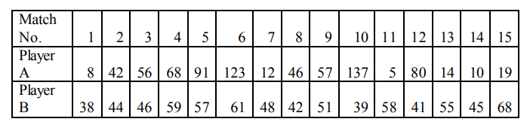
1. For the given data set representing the runs scored by two players in last 15 matches, conduct the following analysis:
i. Which average you will use to summarize the performance of the player? Find average runs scored for both of the players. Also give reasons for the choice of the average?
ii. If selection is possible on the basis of consistency, which player would you choose in the team? Perform the required statistics and justify the selection.
iii. Check whether there exists any relationship among the runs scored by two players using Karl Pearson coefficient of correlation and interpret the same. (10 Marks)
Ans :
i) To summarize the performance of the player we will use Mean of the runs. The mean of run of player A is 51.2 and player B is 50.133.
Here we use Arithmetic Mean

2. On the basis of the following data, the marketing manager wants to predict the sales volume for the locality on the basis of # households, number of cars and marketing expense
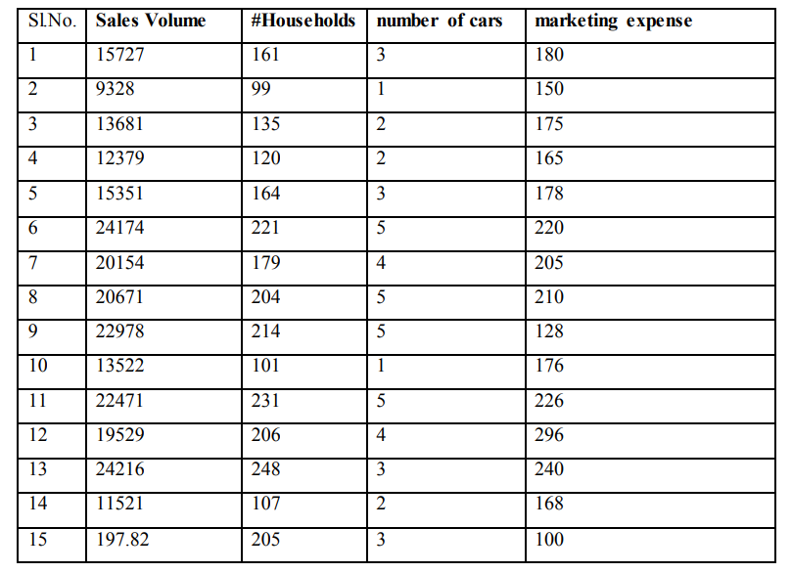
i. Draw three scatter plots of sales volume with each of the three variables and comment on their correlation.
ii. Regress the sales volume on #household, number of cars and marketing expense. Calculate R square and interpret the same.
iii. Determine which variable is/are significant variable/s. Is there any insignificant variable? If yes, regress again, by dropping the variable. Will dropping that variable increases the adjusted R square? (10 Marks)
Ans :
i)
A scatter plot (aka scatter chart, scatter graph) uses dots to symbolize values for two specific numeric variables. The position of every dot on the horizontal and vertical axis indicates values

3. a. The height of the students in a certain class is following normal distribution with mean height as 165 cm and standard deviation of 25 cm. There are 60 students in that class. Determine
i. The number of students whose height is more than 158 cm.
ii. The number of students whose height is lying between 155 and 172 cm. (5 Marks)
Ans :
i. The number of students whose height is more than 158 cm.
p=165 cm and a=

Its half solved sample only

NMIMS Fully solved assignment available for session JUNE 2020,

your last date is 15 june 2020.

Lowest price guarantee with quality. On our website www.aapkieducation.com

Charges INR 199 only per assignment. For more information you can get via mail or Whats app also

Mail id is aapkieducation@gmail.com

After mail, we will reply you instant or maximum

1 hour.

Otherwise you can also contact on our

whatsapp no 8791490301.
Contact no is +91 87-55555-879.

